Week 2 Task Report
Supervised Machine Learning Models
Regression and Classification using Scikit-learn

Field | Details
Name | Sharvin Chaure
Internship | Yuva Intern
Task | Week 2: Supervised Machine Learning Models
Date | 05/10/2026
Tools | Python 3, Scikit-learn, Pandas, NumPy, Matplotlib

1. Introduction
Supervised learning is the branch of Machine Learning in which a model learns from labelled examples, that is, data where the correct answer is already known. The trained model can then predict the answer for new, unseen data. Supervised problems fall into two groups: regression, where the target is a continuous number (for example a price or a disease score), and classification, where the target is a category (for example benign or malignant).
The objective of this Week 2 task was to implement the main supervised algorithms (Linear Regression, Logistic Regression, Decision Trees, Random Forest and K-Nearest Neighbors), learn the full cycle of model training, prediction and evaluation using performance metrics, and train at least two models and compare their performance. In this report, four models were trained and compared for a regression problem and four for a classification problem, which gives eight trained models in total, covering all five required algorithms.

2. Tools and Libraries Used
- Scikit-learn: datasets, train-test splitting, models, pipelines, cross-validation and evaluation metrics.
- Pandas and NumPy: data handling and numerical operations.
- Matplotlib: charts for model comparison, confusion matrix and feature importance.

3. Datasets
Two well-known datasets that are built into Scikit-learn were used, so the work is fully reproducible without any download.
 | Regression | Classification
Dataset | Diabetes dataset | Breast Cancer Wisconsin dataset
Samples / Features | 442 / 10 | 569 / 30
Target | Disease progression one year after baseline (continuous, range 25 to 346, mean 152.1) | Tumour type: 357 benign (1) and 212 malignant (0)
Features | age, sex, bmi, bp and six blood-serum measurements (s1 to s6), already standardised | 30 measurements of cell nuclei such as radius, texture, perimeter, area and concavity
Train / Test split | 353 / 89 (80% / 20%) | 455 / 114 (80% / 20%, stratified)

4. Methodology
The same workflow was followed for every model so that the comparison is fair:
- Train-test split: 80% of the data was used for training and 20% was kept aside as unseen test data. random_state=42 makes the split repeatable. For classification, stratify=y keeps the benign/malignant ratio the same in both parts.
- Scaling inside pipelines: KNN and Logistic Regression depend on distances and gradients, so StandardScaler was added through make_pipeline. This fits the scaler only on training data and prevents data leakage. Tree-based models do not need scaling.
- Training and prediction: model.fit(X_train, y_train) learns from the training data and model.predict(X_test) produces predictions on the test data.
- Evaluation: each model was scored on the test set with task-appropriate metrics, and also with 5-fold cross-validation to check that the result does not depend on one lucky split.
X_train, X_test, y_train, y_test = train_test_split(
X, y, test_size=0.2, random_state=42)
model = make_pipeline(StandardScaler(), KNeighborsClassifier(n_neighbors=5))
model.fit(X_train, y_train)
y_pred = model.predict(X_test)
cv = cross_val_score(model, X, y, cv=5)

Evaluation metrics used
Metric | Meaning
MAE | Mean Absolute Error: the average size of the prediction error, in the units of the target. Lower is better.
MSE / RMSE | Mean Squared Error and its square root. They punish large errors more heavily. Lower is better.
R² score | Share of the variation in the target explained by the model. 1.0 is perfect and 0 equals predicting the average.
Accuracy | Share of all predictions that are correct.
Precision | Of the cases predicted as the positive class, how many really are positive.
Recall | Of all real positive cases, how many the model found.
F1-score | Harmonic mean of precision and recall, a single balanced score.
ROC-AUC | How well the model ranks positives above negatives across all thresholds. 1.0 is perfect.

5. Part A: Regression Models
The regression task is to predict the disease progression score of a patient from ten baseline measurements. Four regression algorithms were trained.

5.1 Linear Regression
Linear Regression fits a straight-line (hyperplane) relationship, y = b0 + b1x1 + b2x2 + ... + bnxn, by minimising the squared error. It is simple, fast and easy to interpret. The largest positive coefficients were for s5 (736.2), bmi (542.4) and s2 (518.1), and the largest negative one was for s1 (-931.5). This shows that body-mass index and serum measurements are the main drivers of the predicted progression, although s1 and s2 are correlated with each other, so their individual coefficients should be read with caution.
from sklearn.linear_model import LinearRegression
lin = LinearRegression().fit(X_train, y_train)

5.2 Decision Tree Regressor
A decision tree repeatedly splits the data on the feature and threshold that best reduce the error, and predicts the average target value in each leaf. The depth was limited to max_depth=4 to prevent the tree from memorising the training data.

5.3 Random Forest Regressor
A Random Forest trains many decision trees (200 here) on random samples of the data and averages their predictions. Averaging reduces the variance of a single tree and usually gives more stable results.

5.4 K-Nearest Neighbors Regressor
KNN predicts the average target of the k most similar training samples (k=10 here). It makes no assumption about the shape of the relationship but depends on distances, so the features were scaled first.

5.5 Regression Results
Model | MAE | MSE | RMSE | R² | CV R² (5-fold)
Linear Regression | 42.79 | 2900.19 | 53.85 | 0.453 | 0.482
Decision Tree | 47.05 | 3568.97 | 59.74 | 0.326 | 0.286
Random Forest | 43.64 | 2897.62 | 53.83 | 0.453 | 0.434
KNN (k=10) | 45.11 | 3168.35 | 56.29 | 0.402 | 0.429

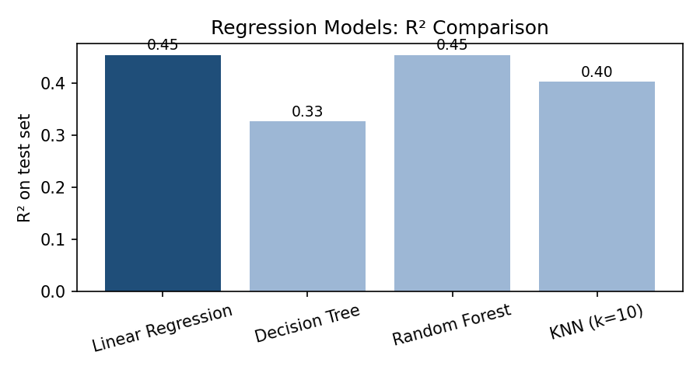
Figure 1: R² score of the four regression models on the test set
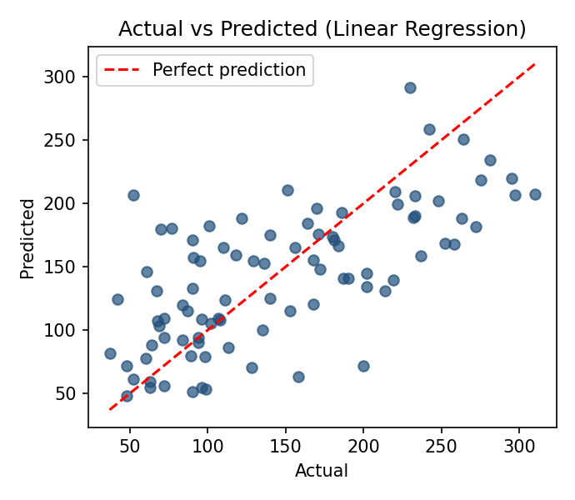
Figure 2: Actual versus predicted values for Linear Regression
Interpretation. Linear Regression gave the best overall result: it had the lowest MAE (42.79) and the highest cross-validated R² (0.482). Random Forest matched its test R² (0.453) but was slightly worse on MAE and cross-validation. KNN followed (R² 0.402), and the single Decision Tree was the weakest (R² 0.326, CV R² 0.286), which shows that one shallow tree is unstable. An R² of about 0.45 means the models explain roughly 45% of the variation, which is typical for this noisy medical dataset, where an average error of about 43 points remains. Because the relationships in this dataset are close to linear, the simple linear model was as good as the more complex ones.

6. Part B: Classification Models
The classification task is to decide from 30 cell-nucleus measurements whether a breast tumour is malignant or benign. Four classification algorithms were trained.

6.1 Logistic Regression
Despite its name, Logistic Regression is a classifier. It applies the sigmoid function to a weighted sum of the features to produce a probability between 0 and 1, and predicts benign when the probability is above 0.5. The features were standardised and max_iter=1000 was set to make sure the optimiser converges.

6.2 Decision Tree Classifier
The decision tree asks a sequence of yes/no questions about the features. Depth strongly affects its quality: at max_depth=10 the tree reached 100% training accuracy but only 91.2% test accuracy, which is overfitting. A shallow tree (best depth 3) generalised better with 93.9% test accuracy, so max_depth=4 was used.
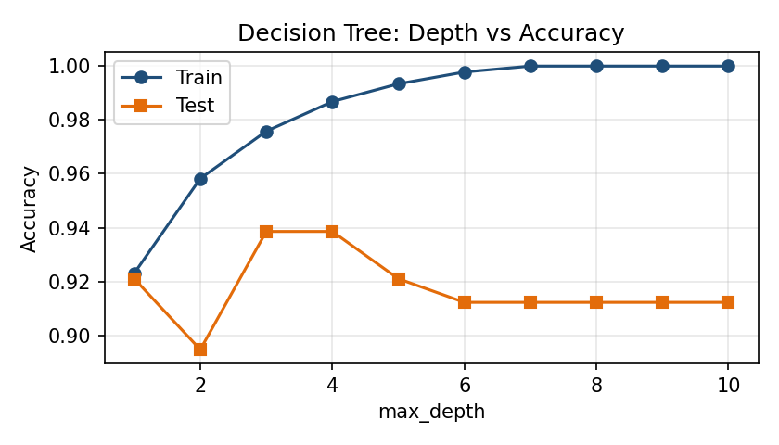
Figure 3: Decision tree accuracy for different depths (overfitting at large depth)

6.3 Random Forest Classifier
The Random Forest combines 200 trees by majority vote. It also reports feature importance. The most important features were worst perimeter (0.133), worst area (0.128), worst concave points (0.108), mean concave points (0.094) and worst radius (0.091), which means tumour size and the irregular shape of the cell nuclei are the strongest signals of malignancy.
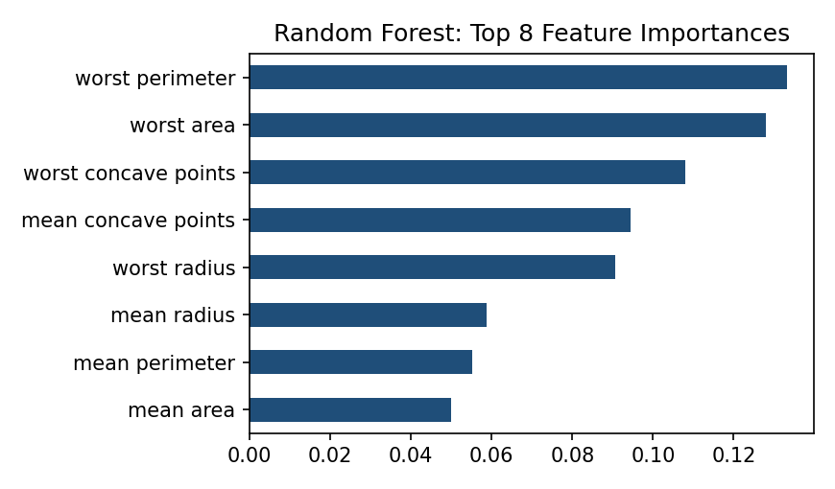
Figure 4: Top 8 feature importances from the Random Forest

6.4 K-Nearest Neighbors Classifier
KNN assigns the majority class among the k closest training samples. The value of k matters: very small k is sensitive to noise, and very large k blurs the class boundary. Testing k from 1 to 25 showed the best test accuracy (98.2%) at k=3. The reported model uses the common default k=5. Choosing k by looking at the test set slightly favours that result, so in practice k should be tuned with cross-validation on the training data.
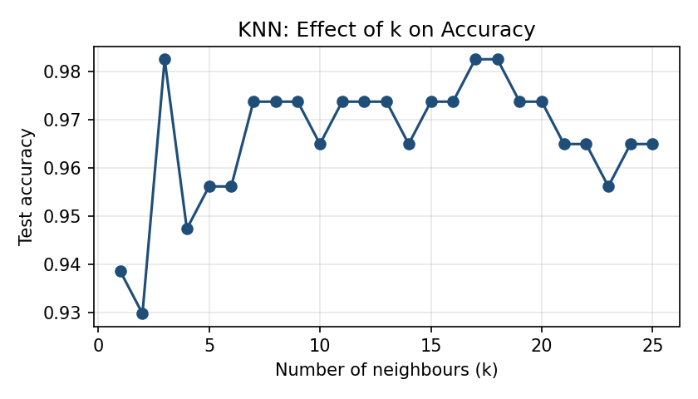
Figure 5: KNN test accuracy for k = 1 to 25

6.5 Classification Results
Model | Accuracy | Precision | Recall | F1 | ROC-AUC | CV Acc.
Logistic Regression | 0.982 | 0.986 | 0.986 | 0.986 | 0.995 | 0.981
Decision Tree | 0.939 | 0.958 | 0.944 | 0.951 | 0.934 | 0.921
Random Forest | 0.956 | 0.959 | 0.972 | 0.966 | 0.993 | 0.958
KNN (k=5) | 0.956 | 0.959 | 0.972 | 0.966 | 0.979 | 0.965

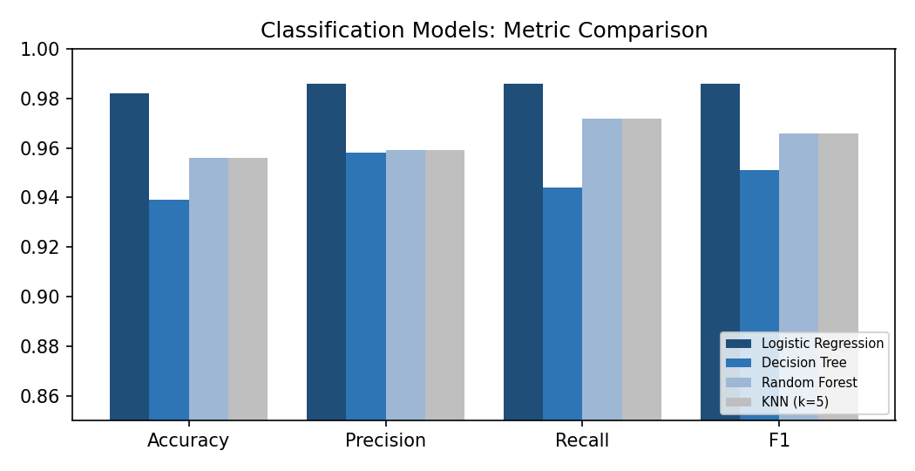
Figure 6: Accuracy, precision, recall and F1 of the four classifiers
Confusion matrices (test set, 114 samples). Each cell shows how many tumours were classified correctly or incorrectly.
Model | Malignant found (TN) | Malignant missed (FP) | Benign flagged as malignant (FN) | Benign found (TP)
Logistic Regression | 41 | 1 | 1 | 71
Decision Tree | 39 | 3 | 4 | 68
Random Forest | 39 | 3 | 2 | 70
KNN (k=5) | 39 | 3 | 2 | 70

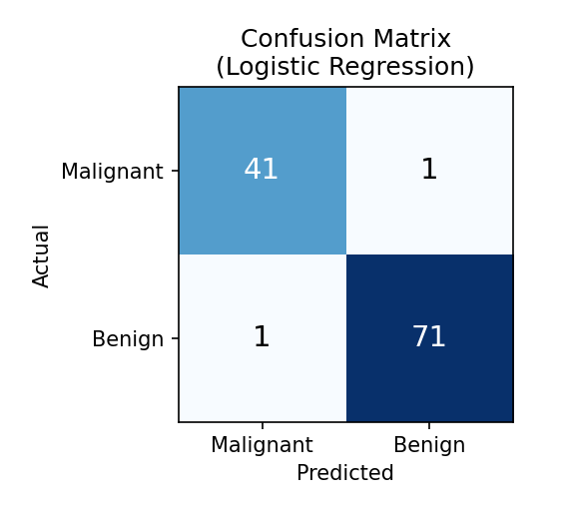
Figure 7: Confusion matrix of the best classifier (Logistic Regression)
Interpretation. Logistic Regression was the best model with 98.2% accuracy, an F1-score of 0.986 and a ROC-AUC of 0.995. It made only two mistakes out of 114 test samples. Random Forest and KNN were tied at 95.6% accuracy, and the Decision Tree was the lowest at 93.9%. Cross-validation confirmed the same ranking, so the result is not a coincidence of one split. In a medical problem the most dangerous error is a malignant tumour predicted as benign. Logistic Regression missed only 1 such case, while Random Forest, KNN and the Decision Tree each missed 3. A model for real use would also be tuned to reduce that specific error.

7. Overall Comparison and Discussion
Algorithm | Strengths | Weaknesses
Linear / Logistic Regression | Fast, simple, interpretable; best results on both datasets here | Assumes a linear relationship; needs scaled features
Decision Tree | Easy to visualise; no scaling needed | Overfits easily; unstable; weakest on both tasks
Random Forest | Robust, reduces overfitting, gives feature importance | Slower and harder to interpret
KNN | No training phase; flexible | Needs scaling; slow on big data; sensitive to k

A key finding is that a more complex model is not automatically better. On both datasets the simple linear models were the best or tied for the best, which is common when the underlying relationship is close to linear. The single decision tree was the weakest, and combining many trees in a Random Forest clearly improved it, which demonstrates the benefit of ensemble learning.

8. Key Learnings and Challenges
- Regression and classification need different metrics: R², MAE and RMSE for continuous targets, and accuracy, precision, recall, F1 and ROC-AUC for categories.
- Accuracy alone can hide important errors; the confusion matrix shows which kind of mistake a model makes, which matters greatly in medical data.
- Scaling must be done inside a pipeline so that test data never influences training (no data leakage).
- Hyperparameters such as tree depth and k in KNN directly control the balance between underfitting and overfitting.
- A single train-test split can be misleading, so cross-validation was used to confirm the model ranking.
- The Diabetes dataset is noisy, so even the best model reached an R² of only about 0.45. This is a data limitation, not a coding error.

9. Conclusion
In this task, eight supervised models were built with Scikit-learn: Linear Regression, Decision Tree, Random Forest and KNN for regression, and Logistic Regression, Decision Tree, Random Forest and KNN for classification. Each was trained, used for prediction and evaluated with suitable metrics and cross-validation. Linear Regression performed best for predicting diabetes progression (R² 0.453, MAE 42.79), and Logistic Regression performed best for breast cancer classification (accuracy 98.2%, F1 0.986). The work gave practical experience of the complete supervised learning workflow and of how to choose and compare models on evidence rather than assumption.

Appendix: Files Submitted
- supervised_models.py: complete Python script that trains, evaluates and compares all models and creates the charts.

